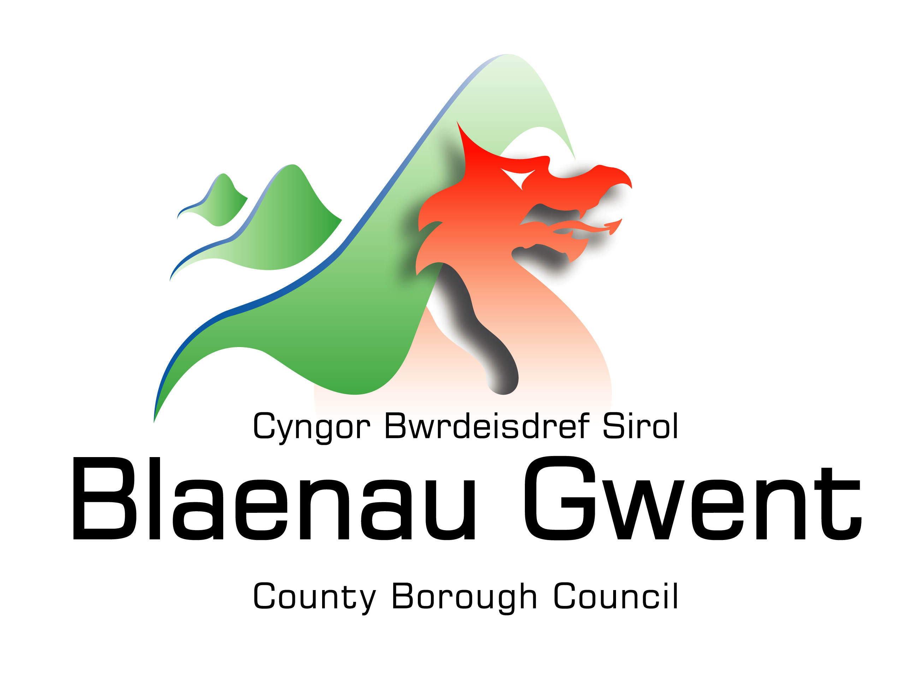

Blaenau Gwent County
Borough Council

“Owner Occupiers”

Home Improvement & Property Appreciation Loan Schemes

This leaflet tells you about Blaenau Gwent Council’s Home Improvement Loan Scheme for Owner Occupiers.

- Please note that all loans are secured with a Legal Charge on the property. Before committing yourself to the loan you are advised to consult your own solicitor to discuss the legal implications
- Before committing to this loan application it is advised to get your own independent financial advice.

Home Improvement Loan Scheme
The ‘Home Improvement Loan’ scheme is funded by the Welsh Government to provide interest-free loans for housing improvements. Improvements could be any work that is needed to make a home safe, warm or secure. There is no automatic entitlement to this loan. Loans are subject to available funding and there may be waiting list on times.

Loans
The minimum loan is £1,000.

The maximum loan for one flat or house is £25,000, provided this does not amount to more than 80% of your home’s current value. If you have a mortgage, the amount you owe, plus the amount of the loan, must be less than 80% of your home’s current value.

Loan Security
We will register a financial charge against the property at the Land Registry. If you already have a mortgage, you will need to obtain the consent of your first lender to register the financial charge. (Before committing yourself to the loan you may wish to consult your own solicitor or financial advisors to discuss the implications)

Affordability & Fees
If you take out a loan but fail to repay it, your home will be at risk. To make sure that you can afford to repay the loan, you will need to complete an affordability assessment with the Credit Union. The Credit Union will then advise us what level of repayments you should be able to afford. The loan is interest-free, unless you default.

(Applicants must pass relevant affordability tests, have no adverse credit history and must not have any unpaid/overdue other debts with the local authority at the time of application.)
Please note: (No Home Improvement Loan application will be considered if the Credit Union Assessment is deemed ‘Unaffordable’. We are unable to challenge or overturn any decision made by the Credit Union.)
Default of Payments
If you default on the loan, interest will be charged at 3.2% per annum of the loan amount from the date issue.

Repayment
The maximum loan period is 10 years for Owner Occupiers. In most cases it will be advisable to repay in a shorter term to allow a safety margin. We will agree a loan period with you based on the affordability assessment. We will ask you to make monthly repayments by direct debit from your bank account.

General Improvement Works
The council is unable to offer an agency service for general improvement works. If you are applying for a loan to cover general improvement works to your home, you will need to find reliable contractors who can do the work for you and ask them to give you a quote for the work. You should get quotes from at least two contractors and send these in with your loan application. We will visit your property to see what you are planning to do but Blaenau Gwent Council is not responsible for the works you carry out; you will be responsible for employing the contractors and supervising the work. However, if needed in some circumstances Practical Assistance can be offered. Please ask for further details if you feel you need this assistance.

Payment of the Loan
The loan will be paid to you in full once the works have been completed. We can consider different payment options if needed (please contact us to seek further information.

Property Appreciation Loans (PAL’s)

This is a new loan product in Blaenau Gwent, which will be made available to owner-occupiers, who cannot meet the affordability test for Owner-Occupier Loans and who need to undertake works to enable them to continue to live independently in their own homes and/or in a safe, warm and secure environment

A Property Appreciation Loan (PAL) is a type of equity release loan product with no monthly repayments. The loan is repaid when the property is sold or transferred to someone else. When the loan is issued it is calculated as a percentage value of the property and the amount that is repaid is based on the same percentage of the property value at the point in time that the property is sold/transferred to someone else (subject to a minimum repayment of the original loan amount). For example, a loan of £10,000 on a property worth £50,000 equates to a 20% equity loan. If the property is later sold for £80,000 then the amount repayable is 20% of the price i.e. £16,000.
Key features:
- Applicants must be Owner-Occupiers.
- Minimum Loan £1,000; Maximum Loan £25,000 per unit
- Maximum loan to value ratio 80%.
- Repayment terms – the loan is repaid on the sale or transfer of the property to someone else. There is no maximum term.
- Applicants must have failed the affordability test for the Owner-Occupier loan, have no adverse credit history and must not have any unpaid/overdue other debts with the local authority at the time of application.
- Fees – No fees are charged to the applicant. All legal and other costs in administering and approving the loan application will be met by the local authority.
- Security – Loan amount and percentage to be a registered first or second property charge with the Land Registry. If at point of re-sale/transfer to someone else, the property has depreciated in value, then the original loan amount would need to be repaid).
- Eligible Works/Costs – Works to eliminate Category 1 and 2 Hazards (as defined under the Housing Act 2004 and/or to leave the property in a safe, warm and secure condition. Reasonable incidental costs relating to the proposed works (e.g. Planning, Building Regulation, Architectural and Welsh Water agreement fees etc.).
- Practical Assistance – in some circumstances practical assistance can be offered. Please ask for further information if required.

The Application Process
Please use either of the following communication methods to request an application form for the scheme you are wishing to apply for:

Address: Housing Advice Centre, 20 Church Street, Ebbw Vale. NP236BG
Email: housing@blaenau-gwent.gov.uk
Phone: 01495 354600 (Option 1)

What happens when we received your completed ‘Application Form’

We will:
- Check, from the information you have given whether your application will meet the rules of the scheme. Make a decision on your application based on the Credit Union’s affordability assessment (the application will not proceed if the loan is deemed unaffordable).
- Check available funding to ensure there is enough money to allow the loan to go ahead. If there is insufficient funding you will be notified of this and placed on a waiting list.
- Visit your home to check its general condition and discuss the works you want to do.
- Contact you to confirm the loan has been approved, the amount you wish to borrow and repayment schedule.
- Send you a loan agreement, including the repayment schedule, a legal charge document and a direct debit form for you to sign - you must return these within 8 weeks if you wish to take up the loan.
Works to be completed within the agreed time scale and the money will be released at the end. (A visit from an officer will be required to verify the works)
Works to be completed within the agreed time scale and the money will be released at the end. (A visit from an officer will be required to verify the works)
Works to be completed within the agreed time scale and the money will be released at the end. (A visit from an officer will be required to verify the works)

