Housing Register – Walkthrough

Stage 1 – Accessing the Housing Register

Firstly, our webpage can be located here [https://www.blaenaugwenthomes.org.uk]

This will bring open the homepage. To locate the register please follow below:

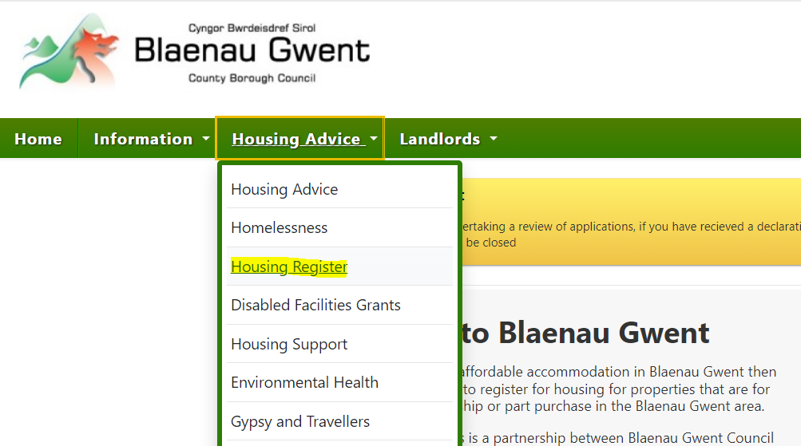

Click the highlighted link ‘Housing Register’ above and you will be greeted with a new page. This page has the link to begin your registration process. As shown highlighted below.

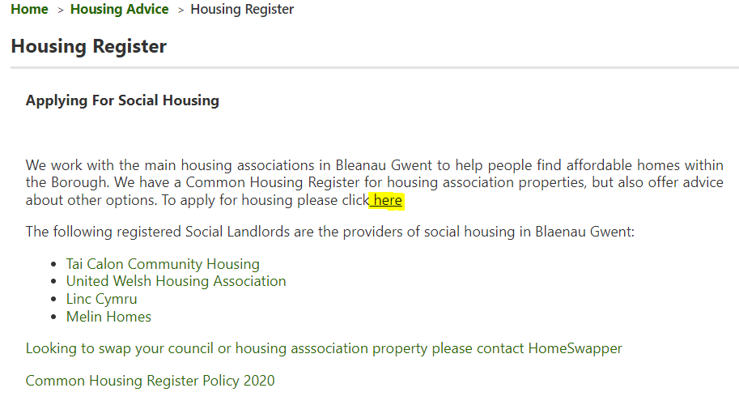

Step 2 – Beginning your registration

At this page you will be expected to enter your National Insurance number, if it’s a joint application enter yours and the joint applicants National Insurance number. However, if it’s a sole application, only enter one National Insurance number.

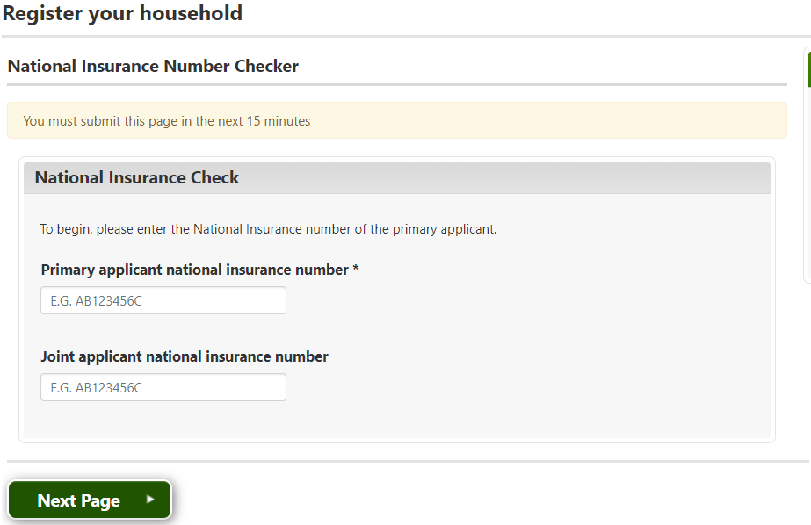

Step 3 – Detail Entry

After you’ve entered your National Insurance Number, you will be greeted by a details page. Fill these in accordingly. If you currently have no fixed abode, please provide the address of your most recent address or a ‘care of’ address. Once these details are entered you will come to your Login Details. It will be important to take note of the memorable date you enter and your password. Password is a maximum of 10 characters long.

This will be the completion of the website and this will open a new page which will identify your unique login reference. It is also important to take note of this number.

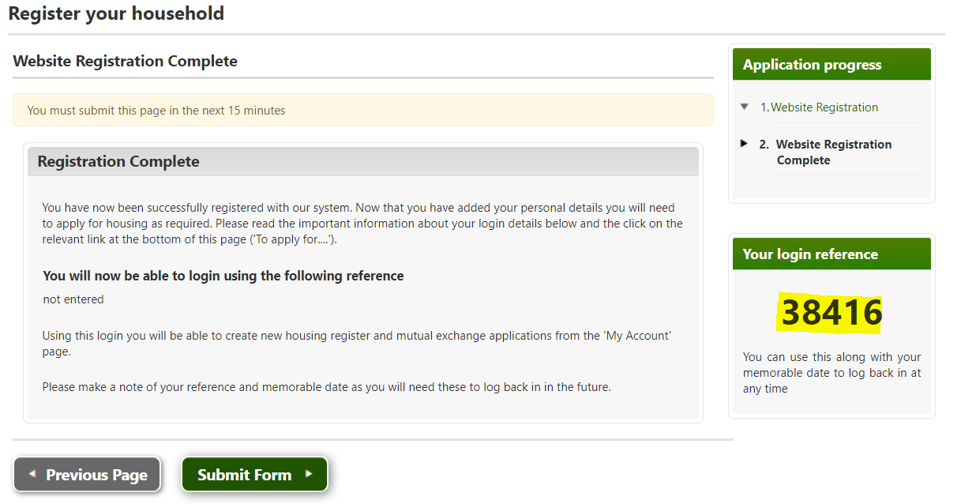

Once you have taken note of your ‘login reference number’, click the ‘Submit Form’ button.

Step 4 – Housing Application Details

You will now be in the ‘My Account’ page. Here you have several options, but to continue with your housing application you need to click the link highlighted below.

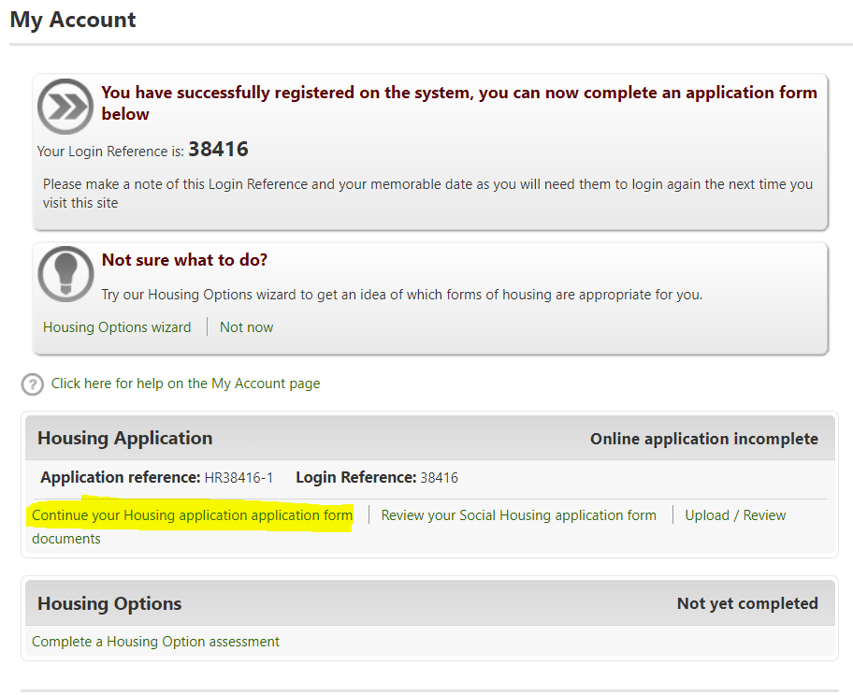

In this instance the link says continue your housing application form. However, this is because in the example used it’s been started. If fresh it will state ‘Complete a Housing Application’

You will then continue with information entry regarding yourself and any other applicants on the form. This will include, Work, Wages, Ethnicity, Benefits, Previous Addresses and needs of the property you are enquiring for.

Step 5 – Preferred Areas

When personal details are completed you will be greeted by the following page.

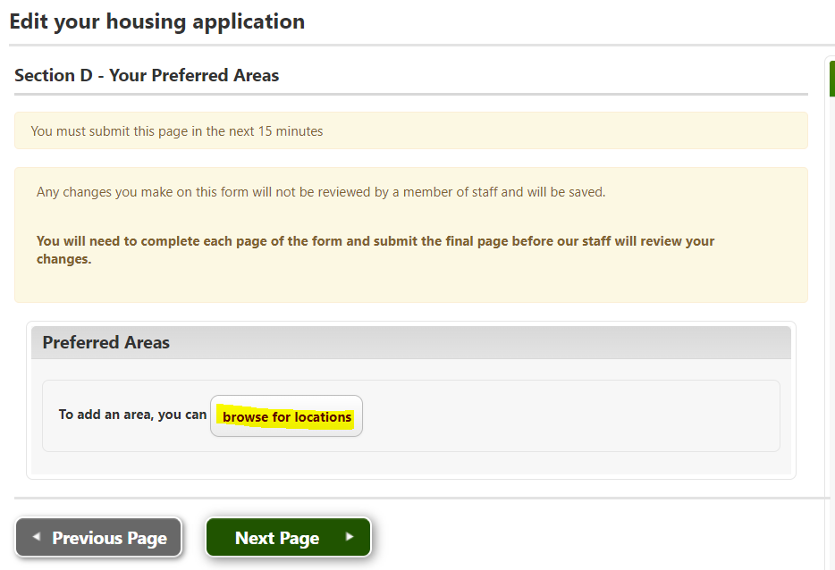

Click the highlighted button ‘browse for locations’ and select preferred areas off this list. Each area is grouped. i.e. Brynmawr – this will contain options of “Brynmawr Town Centre”, “Bryn Farm” Etc.

The more areas selected can increase the speed at which a property can be allocated.

Step 6 – Document Upload

This is where you upload documents of proof of circumstance. This could be Medical, Eviction notices, Child Benefits etc. Anything that is beneficial to your application is to be uploaded here. It’s also required for proof of identity and proof of address. (Bank Statements, Passport etc)

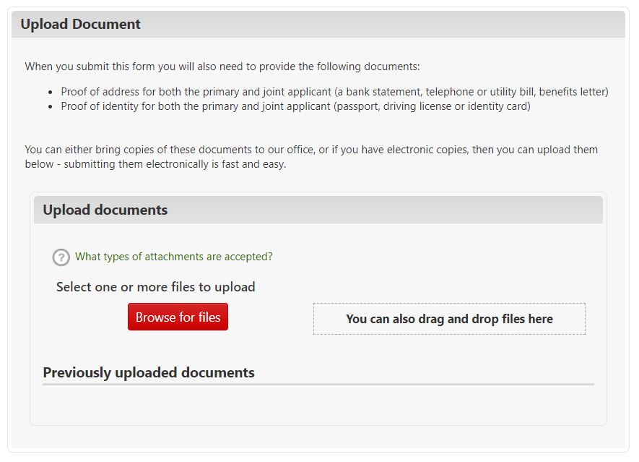
Click ‘Browse for Files’. It is recommended to do this online as it’s more efficient for your application. However if incapable, you can deliver to the Housing Advice Centre for a member of the team to photocopy and add to your application.

Once you click ‘browse for files’ you get to search for your relevant files as shown below.

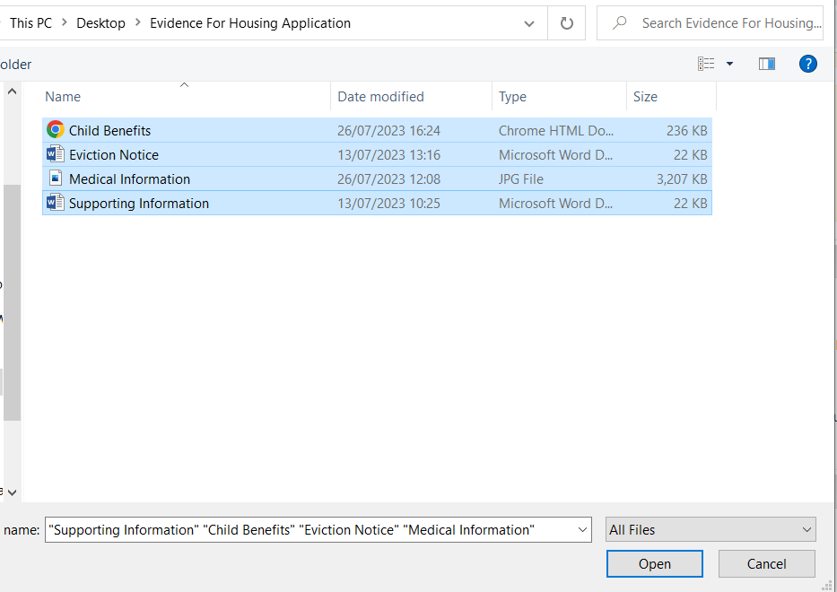

Once these files are selected. Identify the type of document it is via the drop down that appears and click ‘Upload’.

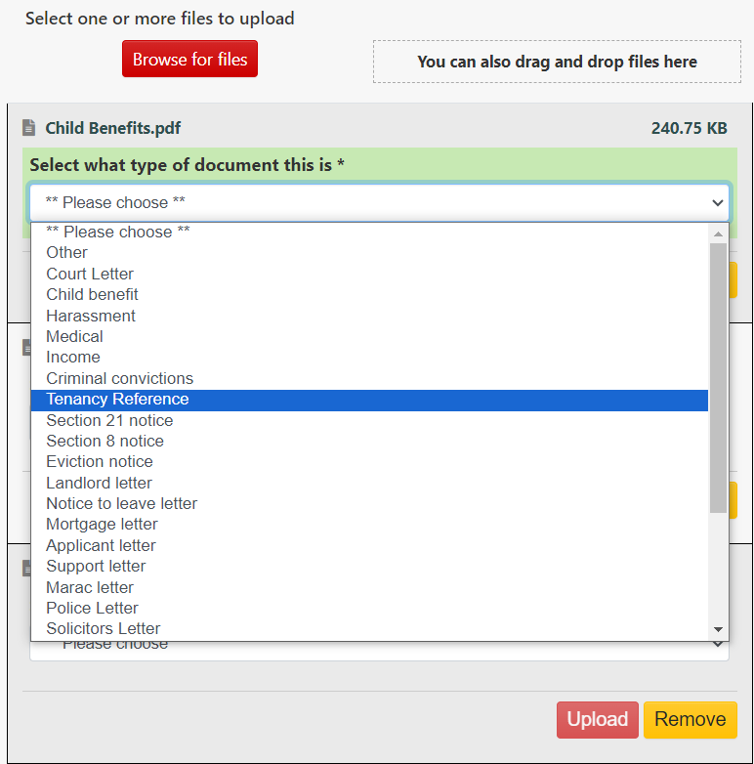

Step 7 – Completion

Once uploaded the next page is a disclaimer and submission of the form.

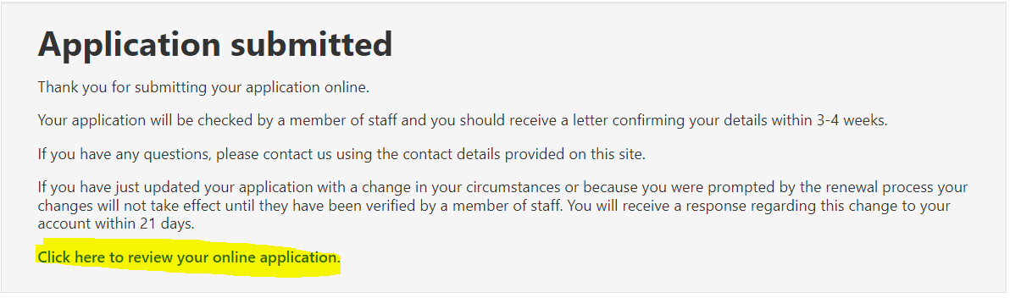

You can also review your application once complete by clocking the link highlighted above.

